Name:_______________

The UP Project

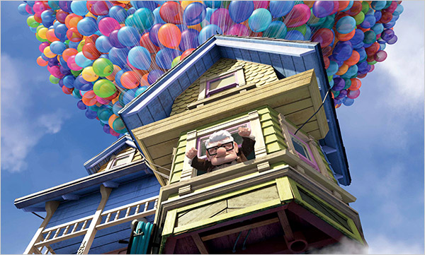

Step 1: Research and describe five different styles of houses. Draw and label the various designs. Select a style of house. This house will be constructed using Popsicle Sticks and HOT GLUE!
Step 2: Find the Density of:
Air-
He-
Step 3: Which of the following is less dense and why is this important?

Step 4: Research Archimedes’ Principle. Explain how it relates to our project. How does the principle apply? (Hint: liquids and gases are both fluids)

Step 5: What is neutral buoyancy?

Step 6: What has to be true about the TOTAL density of your house and the balloons for the house to float in air?

Step 7: How does this project relate to a Hot Air Balloon?

Step 8: Find the mass of your constructed house and the additional mass that will be assigned to you by the teacher at random.

Step 9: A single large balloon filled with Helium will lift approx.___ g. Based on this information calculate the approximate number of balloons need to lift your house. SHOW YOUR WORK.

Goal of this Project: Calculate the number of balloons needed to lift your house. Using the principles learned during your research and come as close as possible to the actual number required.

