Elementary Science Unit Project

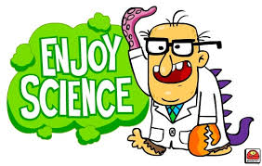
Purpose: Design a science unit that would be suitable for elementary students (grades 3-5). The goal is to make these activities interesting to young children, but also teach one (or more) of the important learning standards that are prescribed by the Massachusetts Department of Elementary and Secondary Education.
Remember that these activities must be able to be performed in each of the Union 61 elementary schools – they do not have lab space, so they must be able to do the activities in their classrooms or on the school grounds.
Each activity that you design should consist of (at least) three parts:
• A summary describing the activity (use the attached summary sheet)
• A hands-on activity/lab experience (should include directions for the teachers AND for the students)
• A way for the teacher to assess student learning
The unit should be a based Massachusetts Science Frameworks http://www.doe.mass.edu/frameworks/scitech/1006.pdf. The unit should be designed to last approximately three days.
Summary Sheet
Elementary Curriculum Project

Topic (Refer to Curriculum Framework):

Grade Level (Refer to Curriculum Framework):

Learning Standard(s) (Refer to Curriculum Framework):

What are the students going to learn during this activity?

What must the students know BEFORE they do this activity?

Are there any particular requirements that must be satisfied in order to carry out your plans? (Ex: particular time of year, classroom space, 3 of students, etc)

